# Union

ntthuat_test:

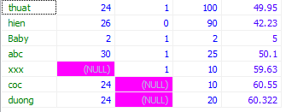

ntthuat_test2:

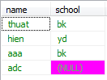

**SELECT** name, age **FROM** ntthuat_test

**union**

**select** name, school **from** ntthuat_test2

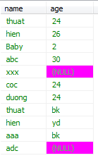

**Union** se ket hop 2 cau select lai voi nhau, va header se lay cai dau tien. Select phai cung so luong column.

# Union all

ntthuat_test2:



ntthuat_test3:



Neu ta su dung **union** **all** thi se show ra tat ca, ke ca thuat-bk 2 lan van show ra 2 lan:

**SELECT** name, school **FROM** ntthuat_test2

**union** **all**

**select** name, school **from** ntthuat_test3

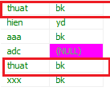

Neu ta su dung **union** thi chi show thuat-bk ra 1 lan:

**SELECT** name, school **FROM** ntthuat_test2

**union**

**select** name, school **from** ntthuat_test3

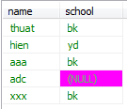

# Select * ben ngoai

ntthuat_test2:



ntthuat_test3:



**select** * **from** (**SELECT** name, school **FROM** ntthuat_test2

**union** **all**

**select** name, school **from** ntthuat_test3) z

**where** z.school = 'bk'

**order** **by** name **desc** **limit** 3;

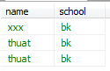

**Sử dụng select * bên ngoài để gán cả câu select bên trong thành alias “z”, như vậy sẽ dễ dàng cho việc sử dụng nó, ví dụ như z.school,…**

**select** * **from** (**SELECT** name, school **FROM** ntthuat_test2

**union** **all**

**select** name, school **from** ntthuat_test3) z

**order** **by** school **desc** **limit** 3;

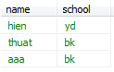

Trong oracle thi khac:

**select** * **from** (**select** * **from** (**SELECT** name, school **FROM** ntthuat_test2

**union** **all**

**select** name, school **from** ntthuat_test3) z

**order** **by** school **desc**) **where** rownum <= 3;